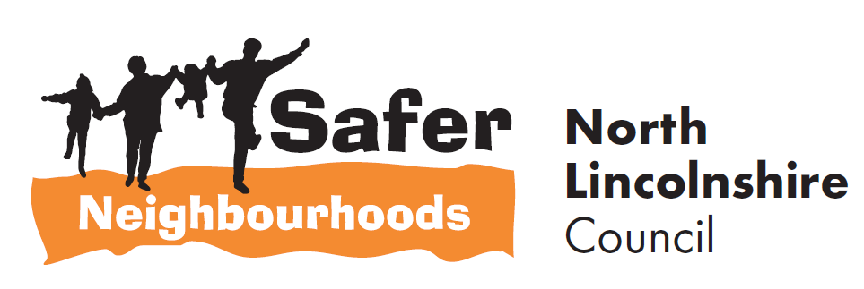


5 minute guide to:
Trade Watch
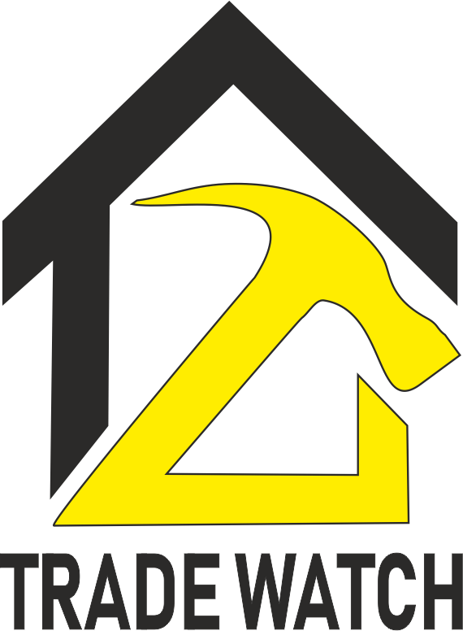
_____________________________________
Prepared by
Safer Neighbourhoods
Church Square House
30-40 High Street
Scunthorpe
DN15 6NL
Tel: 01724-297430
Email: saferneighbourhoods@northlincs.gov.uk

1. Introduction

This ‘5 Minute Guide’ aims to provide a brief guide to North Lincolnshire Trade Watch scheme. Trade Watch was designed and implemented specifically for North Lincolnshire by Safer Neighbourhoods in February 2019 to tackle doorstep sellers and rogue traders.

2. What is Trade Watch

Trade Watch is a voluntary scheme where residents will not agree to any work offered to them on the doorstep and they will report any suspicious company to Humberside Police.
The scheme will protect members of our communities and act as a deterrent to potential rogue traders and criminals in the same way Neighbourhood Watch does. Residents who sign up will receive scheme window stickers and information packs and street signs are available for their villages.
Living in a Trade Watch area will reduce the risk of being approached or becoming a victim of a doorstep crime and send a clear, proactive message to residents and criminals that such crimes will not be tolerated within North Lincolnshire.
3. How is Trade Watch Monitored?
Safer Neighbourhoods will monitor the number of people signed up to the scheme and be able to compare this against reports of suspicious activity. If a resident is targeted this would allow Safer Neighbourhoods to identify the vulnerable residents who would be visited to promote the Nominated Neighbour scheme.

Partner agencies have access to Trade Watch packs and should update Safer Neighbourhoods to any new residents joining the scheme by emailing saferneighbourhoods@northlincs.gov.uk

4. What does a resident need to do, once they have received their Trade Watch Pack

- Display the window sticker in a prominent place,
- Commit to not agreeing to any work offered to them on the doorstep,
- Report any suspicious activity to Humberside Police,
- Promote the scheme to friends, family, and neighbours.

5. Trade Watch Street Signs

Safer Neighbourhoods recommend encouraging neighbours to join or streets and areas be targeted for sign up to the scheme. The use of street signs is a deterrent to rogue traders. Village schemes are encouraged to display the signs on all entrances and exits to the village.
Planning permission for signs is applied for on behalf of residents free of charge through Safer Neighbourhoods.
Lamppost numbers for proposed signs should be sent to Safer Neighbourhoods by emailing saferneighbourhoods@northlincs.gov.uk and we will notify when planning permission is granted prior to the signs being distributed.

Groups and residents are responsible for erecting the signs however support can be offered to assist through Safer Neighbourhoods.

6. What Information does a Trade Watch pack contain

The free Trade Watch pack contains:
- What is Trade Watch leaflet Appendix A
- Humberside Police Information sheet Appendix B
- Trading Standards Information sheet Appendix C
- Branded door/window sticker

About Safer Neighbourhoods

Safer Neighbourhoods is the Crime and Disorder Reduction Department of North Lincolnshire Council and are responsible for contributing to the delivery of the Safer Communities Plan.

Each year, the Partnership carries out an assessment of crime and disorder and develops a plan to tackle the issues identified.

The Safer Neighbourhoods Team are engaged in a wide range of activities including developing strategic plans, problem solving community issues, commissioning services, engagement, education and diversion away from crime.

For more information about this guide or about Safer Neighbourhoods, call us on: 01724-297430 or visit the website www.saferneighbourhoods.net
You can also follow us on Twitter: @SaferNhoodsNL

Appendix A

North Lincolnshire Trade Watch

What is Trade Watch
Trade Watch is a voluntary scheme where residents will not agree to any work offered to them on the doorstep and they will report any suspicious company to Humberside Police.
The scheme will protect members of our communities and act as a deterrent to potential rogue traders and criminals in the same way Neighbourhood Watch does. Residents who sign up will receive scheme window sticker, information packs and street signs are available for villages who sign up.
Living in a Trade Watch area will reduce the risk of being approached or becoming a victim of a doorstep crime and send a clear, proactive message to residents and criminals that such crimes will not be tolerated within North Lincolnshire.

Safer Neighbourhoods will monitor the number of people signed up to the scheme and be able to compare this against reports of suspicious activity. If a resident is targeted this would allow Safer Neighbourhoods to identify the vulnerable residents who would be visited to promote the Nominated Neighbour scheme.

Checklist of things to do to become a member.

I have received my pack and will display the sticker in a front window.

I will encourage my friends and neighbours to be part of the Scheme.

You can contact Safer Neighbourhoods on 01724 297000

Appendix B

North Lincolnshire Trade Watch

TRADING STANDARDS INFO:
  - Contracts made in a consumers home need cancellation rights
    - Criminal offence not to give cooling off period
    - If not given, civilly contract not enforceable i.e. don’t have to pay trader for work done
    - If starting within the cooling off period, a waiver needs to be given in writing
  - Aggressive practises
    - Using coercion and undue influence (High pressure selling), staying in consumers home for hours until they sign
  - False information
    - Claiming work needs doing when it doesn’t, i.e. claiming a consumers chimney needs pointing when it is perfectly OK.
    - Claiming a product will do something when it won’t i.e. claiming a roof paint will help insulate their roof, when it won’t
    - Claiming a job will be one price then inflating it at the end
  - Omitting information
    - Failing to make customers aware in advance the price of the job i.e. failing to tell consumers the pointing of the roof will cost £2000 for a 10-minute job
  - Professional diligent
    - Purporting to be a professional and not meeting the required standard i.e. a professional drive company will lay the new drive on the correct foundation with correct thickness of tarmac. Poor quality may not just be civil!!
Trading Standards can also deal with fraud offences, however this crosses over with the Police and pure fraud offences should really go to the Police.
Please note poor quality work is a civil matter. However, all Trading Standards matter should be reported to the Citizens Advice Consumer Helpline on 03454 040506. They will either provide civil advice or refer on criminal matter to Trading Standards.

Appendix C
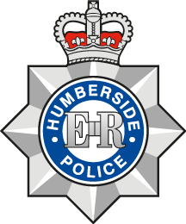

Humberside Police Information
Not all criminals work in the shadows – some are brazen enough to come and knock on your front door.
But if you follow these guidelines from Humberside Police, you can dramatically reduce the risk of becoming a victim of doorstep crime.
Doorstep criminals often target people they think will be vulnerable or elderly, arriving unannounced and trying to convince them they need work done on their home. Many will appear to be working for a reputable, established business and claim that they have noticed issues with your property that they offer to fix. This can be anything from cutting down a tree which they claim has roots that will damage a neighbour’s house to roof tiles in need of repair. Others may offer to do gardening work or build a driveway for a good price, only to demand more money once the job has been finished.
They’re often very persuasive and can become aggressive and intimidating – with some even taking their victims to a cashpoint to withdraw the money. Others knock on your door to distract you while an accomplice breaks into your house through another door or window. They may try and get you to come and look at the ‘problem’ they claim to have spotted, to move you further away and give their accomplice more time.
There are simple steps you can take to avoid falling victim to these criminals:
- Put the chain on before you answer your door and don’t go outside.
- Don’t get drawn into conversation and don’t agree to have any work done by someone who turns up uninvited.
- If you think a caller is genuine, ask to check their identification card. Make sure the photo matches the card.
- Call the company they claim to be from – but always look up the number yourself, as any number they provide could be answered by an accomplice.
If you do want work doing, then you can protect yourself from fraudsters by:
- Getting quotes from at least three different firms
- Ensure you get a written quote. Genuine traders must give you a quote in writing and a 14 day cooling off period.
- Don’t agree to work being done and allow them to start then and there.
- Only pay once the work has been finished and you’re happy with the quality.
- Don’t pay more than the price you agreed.
- Never tell anyone you have money in the house.

Humberside Police work closely with North Lincolnshire Council Trading Standards officers to prevent, reduce and investigate doorstep crime. Offenders can be prosecuted under the Fraud Act and Consumer Protection Act, for instance.
We are delighted to support the Safer Neighbourhoods Trade Watch initiative which will play a major part in protecting vulnerable people, particularly those in rural communities.

If you discover you’ve been the victim of a distraction burglary and the offenders have only just left the area, call us on 999. If you’re concerned about a caller who has been to your house or called on someone you know, please call 101 and tell us about it. Any descriptions of the persons involved or their vehicles is useful, but NEVER put yourself in danger to get this information.

