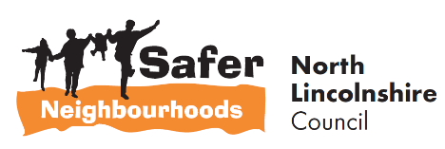


5 minute guide to:
The Red, Amber, Green Scheme

________________________________________

Prepared by

Safer Neighbourhoods
Church Square House
30-40 High Street
Scunthorpe
DN15 6NL

Tel: 01724-297430
Email: saferneighbourhoods@northlincs.gov.uk
Introduction

This ‘5 Minute Guide ’aims to provide a brief overview of the procedures that relate to the North Lincolnshire Red, Amber, Green Scheme that has been developed to address problems with parking on ‘school keep clear’ markings.

Background

Through Neighbourhood Action Teams (NATs) it became apparent that inconsiderate parking outside schools at start and finish times is a very important issue for the residents and communities of North Lincolnshire. The North Lincolnshire Council Road Safety and Traffic Teams work with schools discussing potential solutions, installing School Safety Zones and conducting enforcement where appropriate however, problems around some schools persist.

Red, Amber Green Scheme

Safer Neighbourhoods have worked with Road Safety to develop a Red, Amber, Green Scheme where traffic light coloured banners can be located outside a school depending on the extent of the parking and congestion problems. Each banner displays a differently worded message as shown below:

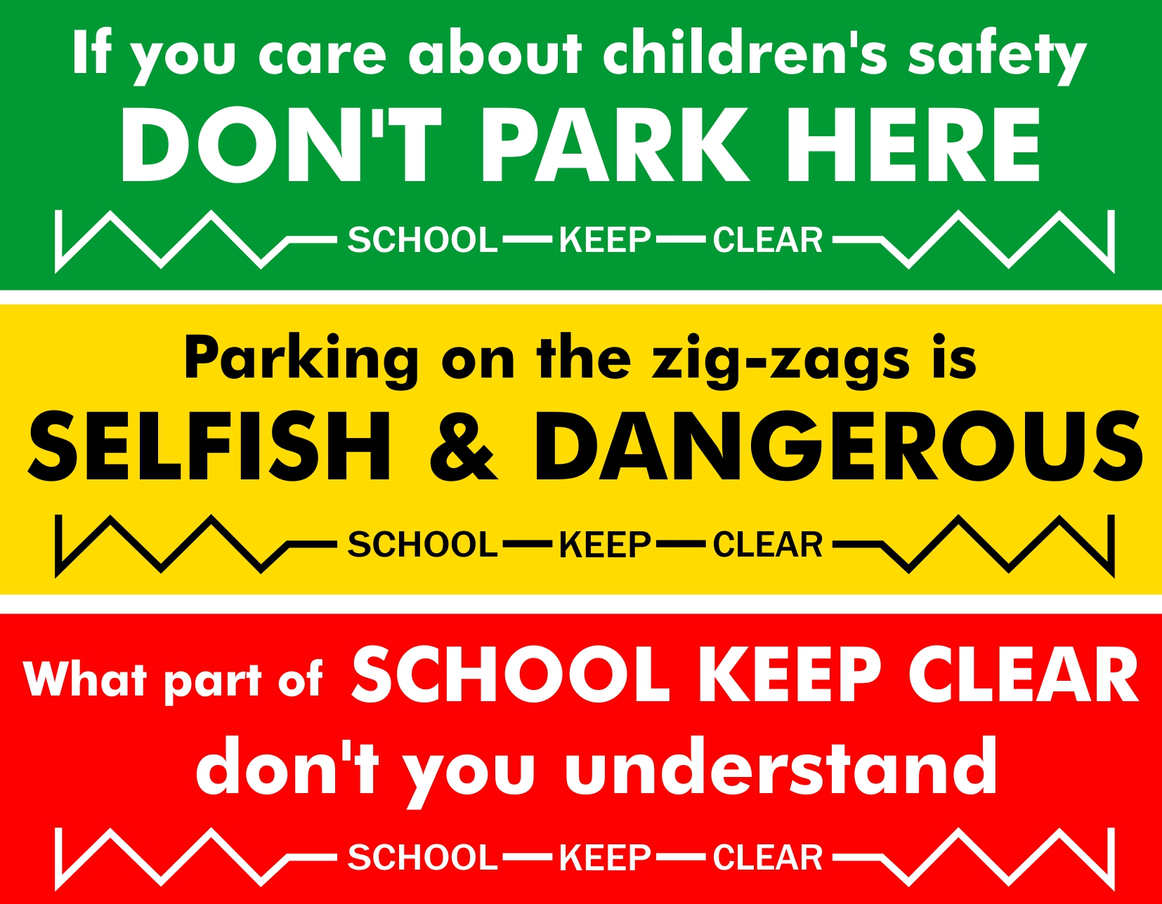

The banners are specifically aimed at tackling parking on the 'school keep clear' markings rather than general parking or other safety issues that may be occurring. Other issues can be discussed with the Road Safety Team or the area Safer Neighbourhoods Officer.

Criteria and process for the Scheme

The issue of persistent parking on the ‘School Keep Clear’ needs to have been raised at the local NAT. These are meetings involving key representatives from the community who discuss and look at ways to tackle community safety issues. Each meeting is attended by a Safer Neighbourhoods Officer; contact can be made to your relevant area Officer by calling the number on the front of this guide.

The Safer Neighbourhoods Officer will contact Road Safety initially to discuss the problems and determine if other measures have been tried previously to alleviate the problems and whether the school has an active travel plan. Contact may also be made with the school, residents, Police, Civil Enforcement Officers to provide evidence of a problem and to determine the severity of these.

If it is determined appropriate and the school qualifies for the scheme a meeting will be held between Safer Neighbourhoods, Road Safety and the school Headteacher to ensure that they agree and are committed to the scheme. An agreement shown at Appendix B will need to be signed. They must agree to monitor the situation during the period the banners are used, reporting the need for the next stage if appropriate.

The school will be required to monitor the effect of the first (green) banner for a maximum of two weeks and if vehicles no longer stop or park on the 'school keep clear' markings by the end of that period then that is the end of the matter and the banner is removed. It could be used again if the problem returns. To be effective the school also needs to communicate with the parents to give feedback on the response to the banners.

If the problem has not been resolved during the first monitoring period then the second (amber) banner can be used and the situation monitored again. Likewise the red banner would only be used if the problem hasn't resolved after this.

We will not automatically expect all three banners be used if they aren't needed. Banners will only be displayed for a maximum of two weeks each. It will be the responsibility of the school to monitor the situation accurately and for the Safer Neighbourhoods Officer to change or remove the banners.

Persistent offenders after all three banners have been used could be written to by the Police (vehicle registration number would be needed). If the markings have a Traffic Regulation Order then some enforcement could also be carried out.

A flowchart of the process can be found at Appendix A

About Safer Neighbourhoods

Safer Neighbourhoods is the Crime and Disorder Reduction Department of North Lincolnshire Council and are responsible for contributing to the delivery of the Safer Communities Plan.

Each year, the Partnership carries out an assessment of crime and disorder and develops a plan to tackle the issues identified.

The Safer Neighbourhoods Team are engaged in a wide range of activities including developing strategic plans, problem solving community issues, commissioning services, engagement, education and diversion away from crime.

For more information about this guide or about Safer Neighbourhoods, call us on: 01724-297430 or visit the website www.saferneighbourhoods.net
You can also follow us on Twitter: @SaferNhoodsNL
APPENDIX A
Process for applying for the Red, Amber, Green Scheme

Problems with parking on a Schools Keep Clear markings raised at NAT
Safer Neighbourhoods Officer discusses the School with Road Safety to identify if the school qualifies for the scheme.
A meeting with Road Safety, Safer Neighbourhoods and the School to discuss the Scheme, obtain their commitment and identify a nominated monitor within the School/Governor
Safer Neighbourhoods will deliver the first green banner, along with tie wraps and ensure it is displayed on the School railings.
Sign will remain for a maximum of 2 term time weeks.
Safer Neighbourhoods make contact with the School who confirm that the situation has improved.
Banner is removed by Safer Neighbourhoods.
Safer Neighbourhoods replace the green banner for an amber banner to remain for a further 2 term time weeks.
Safer Neighbourhoods make contact with the School who confirm that the situation has stayed the same or deteriorated.
Safer Neighbourhoods make contact with the School who confirm that the situation has stayed the same or deteriorated.
Banner is removed by Safer Neighbourhoods.
Safer Neighbourhoods make contact with the School who confirm that the situation has improved.
Safer Neighbourhoods replace the amber banner for a red banner to remain for a further 2 term time weeks.
Banner is removed by Safer Neighbourhoods.
If problems are persisting PCSO’s and Civil Enforcement Officers will be informed. If vehicle registration details are obtained and passed to Safer Neighbourhoods, the registered keepers can be sent a warning letters by the Police.
APPENDIX B

Safer Neighbourhoods
Church Square House
30-40 High Street
Scunthorpe
North Lincolnshire
DN15 6NL
Tel: 01724 297430

Red, Amber, Green Scheme School Agreement

I have had the Scheme explained to me and I am committing my School to be part of it.

I have nominated a point of contact who will have responsibility for monitoring the number of vehicles that park in the School Keep Clears on a daily basis and who will liaise with the Safer Neighbourhoods Officer. That person is:…………………………..

I agree to inform the parents that the scheme will be operating and to appeal for their cooperation. I will feedback on how the banners have impacted the situation.

I understand that the banners are owned and belong to Safer Neighbourhoods who will have the responsibility of putting up and removing them. The banners are on loan to the School and I will immediately report any damage or loss of the banners to Safer Neighbourhoods.

I agree to the above.

Name……………………………………………………………………………

School…………………………………………………………………………

Tel ………………………………………………………………………….

Signature……………………………………………………………………….

Date…………………………………………………………………………….

