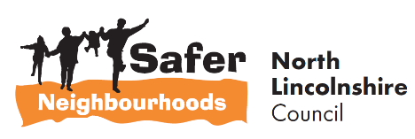


5 minute guide to:
Nominated Neighbour Scheme

________________________________________

Prepared by

Safer Neighbourhoods,
Church Square House
30-40 High Street
Scunthorpe
DN15 6NL

Tel: 01724-297430
Email: saferneighbourhoods@northlincs.gov.uk

Introduction

This ‘5 Minute Guide’ aims to provide a brief overview of the Nominated Neighbour Scheme managed by Safer Neighbourhoods.

The scheme has been launched to tackle the issue of Distraction Burglary and Rogue Traders.

The scheme is only used as part of a Neighbourhood Watch Group to ensure the scheme is implemented and monitored effectively.

How the Scheme Works

This scheme works by the vulnerable person nominating a chosen neighbour who can help to check whether or not a caller to their door is genuine or not.

When the vulnerable person is visited by a caller that they do not recognise, they show the caller a card which directs them to visit the Nominated Neighbour at their address if they live close by or by telephone using the number displayed on the card.

The card should not be left in the window as this may identify the owner as vulnerable.

Packs are distributed to Neighbourhood Watch Coordinators for them to identify elderly and vulnerable residents in their community who may fall victim to unwanted and unsolicited doorstep callers and to identify a local neighbour who can take on the role of Nominated Neighbour.

How the vulnerable person should use the card

- Keep the card handy near the front door, not leaving it on display permanently.
- When someone does call – see if you recognise them but do not open the door.
- If you do not recognise them, show them the card.
- Telephone the Nominated Neighbour and let them know about the caller.
- Wait for the caller to return with the Nominated Neighbour or for the Nominated Neighbour to telephone you with advice on what to do.

The Role of a Nominated Neighbour

The Nominated Neighbour is provided with guidance of how to check caller’s details. If an unrecognised caller has been directed and attends at their door, the Nominated Neighbour is to check their identity, if satisfied they are to return to the vulnerable property with the neighbour, once finished the neighbour is to see the caller off the premise.

If a telephone call is received by the Nominated Neighbour from the unrecognised caller, ideally the neighbour will arrange an appointment to return when they can be present with the vulnerable person.

Nominated Neighbour Follow Up

The Nominated Neighbours are encouraged to report all incidents to their Neighbourhood Watch Coordinators who will inform Safer Neighbourhoods.

Nominated Neighbour packs also contain information on reporting incidents to Humberside Police and Safer Neighbourhoods.

Nominated Neighbour Sign
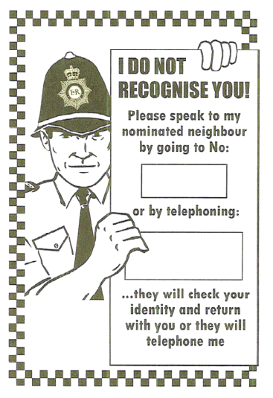

About Safer Neighbourhoods

Safer Neighbourhoods is the Crime and Disorder Reduction Department of North Lincolnshire Council and are responsible for contributing to the delivery of the Safer Communities Plan.

Each year, the Partnership carries out an assessment of crime and disorder and develops a plan to tackle the issues identified.

The Safer Neighbourhoods Team are engaged in a wide range of activities including developing strategic plans, problem solving community issues, commissioning services, engagement, education and diversion away from crime.

For more information about this guide or about Safer Neighbourhoods, call us on: 01724-297430 or visit the website www.saferneighbourhoods.net
You can also follow us on Twitter: @SaferNhoodsNL

