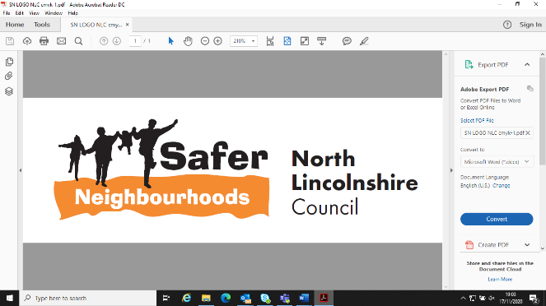


5 minute guide to:
Deployable CCTV

________________________________________

Prepared by

Safer Neighbourhoods
Church Square House
30-40 High Street
Scunthorpe
DN15 6NL

Tel: 01724-297430
Email: saferneighbourhoods@northlincs.gov.uk

Introduction

This ‘5 Minute Guide’ aims to provide a brief guide to the use of Safer Neighbourhoods deployable CCTV cameras.

Types of CCTV

The cameras we use are full colour, with a recording loop of approximately 30 days, the image is recorded on to a hard drive and downloaded on site, via a wireless network onto a laptop, this is then converted and burned to a disc for the investigating officer.

We do have access to a camera that can be viewed away from the location. This also retains footage for 30 days. This camera is designated for extremely high priority issues.

Deployable CCTV process

- The criteria being met and availability of a camera will decide whether a camera will be deployed. (See Request Form below for this).

- CCTV cameras are deployed on Council owned street lighting or on a number of existing CCTV poles installed around North Lincolnshire.

- There is a substantial cost for every deployment of a camera. Safer Neighbourhoods will cover this cost for every deployment that meets the criteria. If a pole and power trunking is required funding for this will need to be sought.

- Requests for downloads need to be emailed to saferneighbourhoods@northlincs.gov.uk This mailbox is only monitored Monday to Friday. Requests needs to include accurate times and dates and must not exceed two hour slots due to the cameras downloading in real time, (exceptional circumstances can be considered).

- Following a request for a camera a Safer Neighbourhoods Officer will visit the site to check the suitability of the location and the lighting column.

- Safer Neighbourhoods will download any images requested within a reasonable timescale dependent upon the incident in question. The Officer will be contacted to say that the footage is ready to collect on a DVD. We do not ordinarily view footage for incidents.

- CCTV camera’s are used at hotspot locations and are not for permanent deployment. Due to demand, cameras will be deployed for a minimum of 3 months. The number of downloads will be monitored and assessed on a Red, Amber, Green needs basis. After 3 months if the camera is assessed as green it will be deployed at an alternative location.

- CCTV warning signs will be erected in the area of camera.

- Safer Neighbourhoods retains the right to move any camera at any time.

Before requesting a camera, consider

- A camera may be of use as a monitoring tool, depending on the issue. Requests will need to as part of the SARA process when addressing a community priority.

- In certain circumstances, a CCTV camera may help resolve a temporary problem/issue (for example, during an event) but may not resolve the problem as other factors will need to be addressed and considered.

- CCTV is only part of a solution and although it can be a deterrent, different problem solving responses need to be considered to address an issue long term.

- Requests for a camera may be spurious, based on unrealistic perceptions of their capabilities and may not address the issue for its intended purpose.

- The cameras do not have the capability of ‘live’ monitoring, therefore they can’t be used as a response to incidents as they occur. It is only evident what a camera has capture of evidential value when we attend to download required footage.

- Deploying temporary CCTV may lead to a demand for the camera/ CCTV to be a permanent fixture, these expectations need to managed.

Do’s and don’ts of CCTV use

Please note that this document is for your guidance only. It is not a statement of the law. Safer neighbourhoods will make decisions ensuring these acts are not unlawful.

Do’s

 | We do make sure that the camera has a clear field of vision of the area you want to cover.
 | We do consider the lighting conditions in conjunction with the camera if its to record at night. We also consider the season, trees could hinder vision.
 | We ensure the camera position covers what is required, ie, to pan an area or just concentrate on one spot.
 | We consider what required for recording, ie, face recognition or just general movement (see next page).
 | We try and use ‘pinch points’. If face recognition is needed we try to force someone towards a camera to get a good image of their face, (eg: if we know they ride a motorbike up a curtain street or alleyway we deploy the camera monitor that particular area).

Don’ts

 | We don’t point cameras onto private property.
 | We don’t allow our CCTV to be used to intimidate or harass people.
 | We don’t allow the use of the CCTV to affect someone else’s quality of life (for example making them afraid to leave the house or enjoy their garden)
 | These cameras cannot be used as covert, nor can they be used as directed (ability to move and focus on objects) cameras. Except in exceptional circumstances.

Extra information and guidance can be found at: www.informationcommissioner.gov.uk

Image recognition
Dependent upon what you want to achieve. The following images should give you some indication of the level of detail you need for evidence in a court. Please be aware that these are guidelines only.
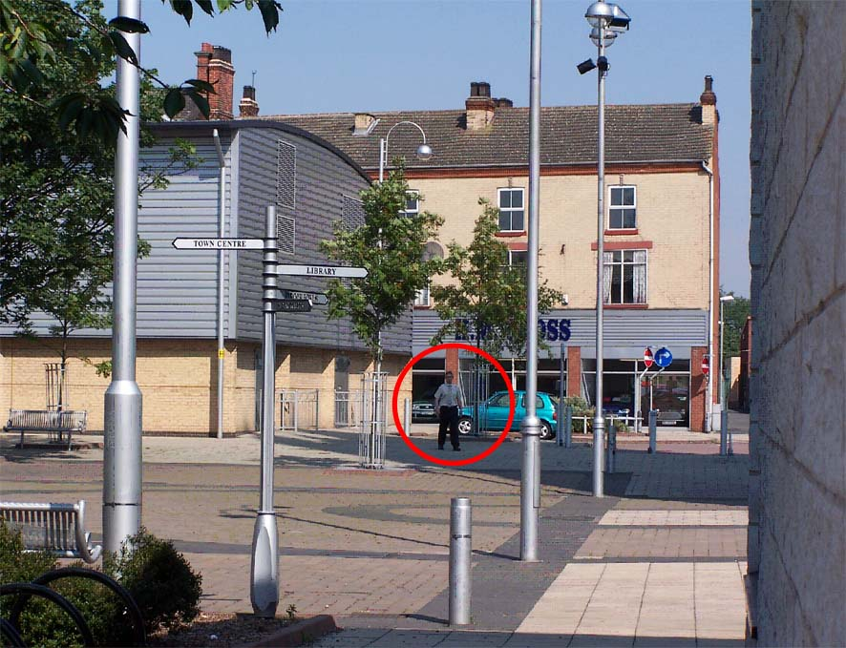 | Monitoring Image  This image is generally used to indicate that there is movement in a large area (such as a car in a car park). All it enables you to do is see that there is a person or other large object moving in the area.
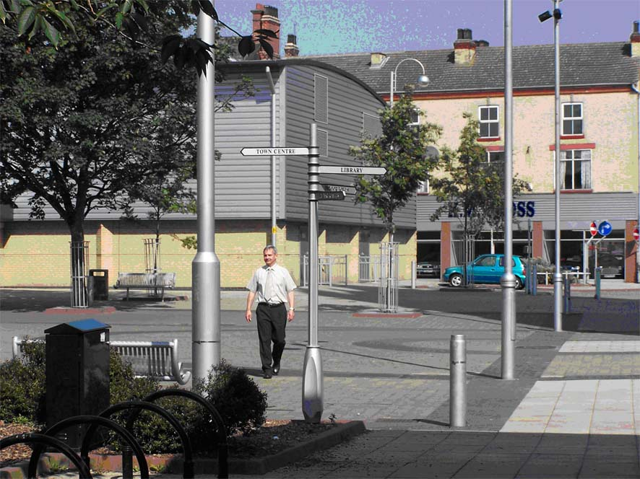 | Detection Image  An image of this size will enable you to see that the person is walking around within the area being viewed and will show some actions (such as a fight or something being thrown). You would not see smaller details for recognition. You would not with any certainty even be able to tell the sex of the person.
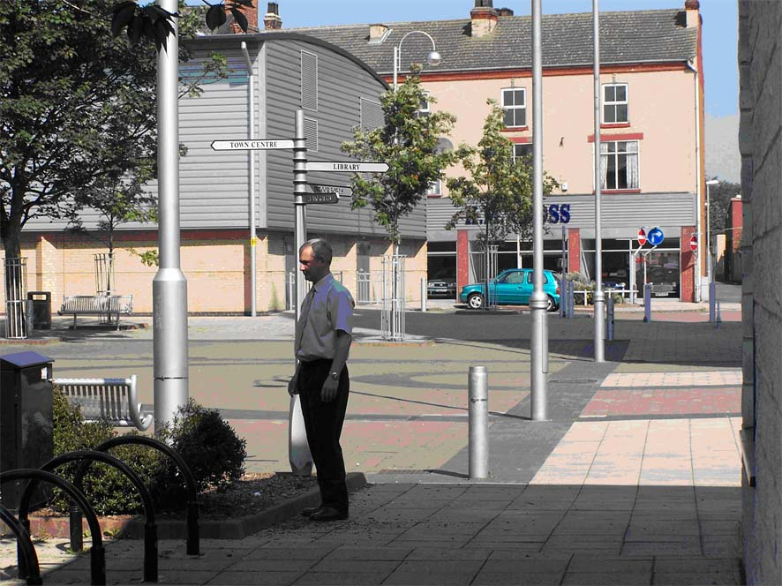 | Recognition Image  This size of image will give an idea of the sex of most subjects. It will also give a little more detail of their actions. Police may be able to recognise a very well known criminal. These images might not be acceptable in a court as proof of identity.
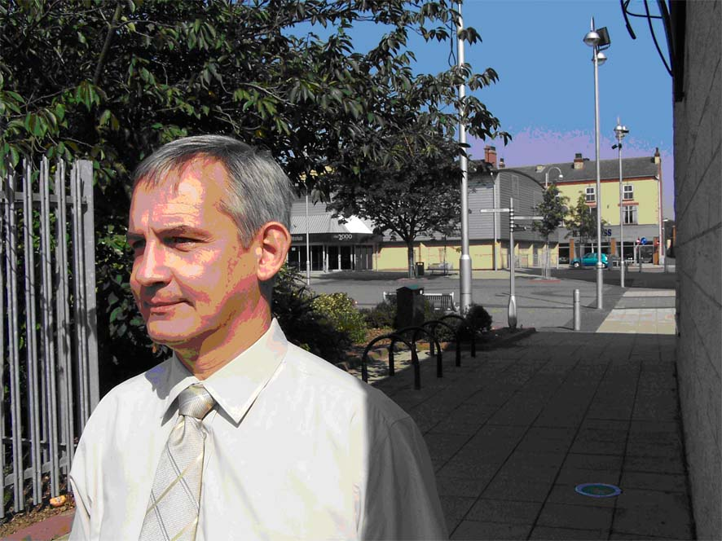 | Identification Image  This is the size of image that gives good detail of actions by the persons being viewed and gives a minimum size of image that may be used as evidence in court proceedings.

SAFER NEIGHBOURHOODS DEPLOYABLE CCTV REQUEST FORM
(When completed please send to saferneighbourhoods@northlincs.gov.uk)

Criteria to request a deployable camera (insert ✓)
There are at least 4 calls for service to the Police in the last 3 months (log numbers to be included)
There is ongoing anti-social behaviour that is crime related
There is a suitable column in place to mount the camera

Why are you asking for a camera? (to include Log No’s and Reference to Statements, Intelligence if appropriate. Problem Profile/SARA)

Where would you like the camera located? (Street Name/Lampost No)

Where would you like the camera to point? (Fixed or Touring/Describe Exact Location to be covered)

What risks are there? (What type of collateral intrusion may occur, will it invade on people’s privacy, will privacy screens be required. Has a privacy impact assessment been completed? Any RIPA requirements?)
No RIPA required
No intrusion

Who is requesting the installation?

I understand that if this request is authorised, the camera will be installed for a minimum of 3 months at which point it will be reviewed in the section overleaf. I understand and agree that the equipment will be removed if its deployment is no longer justified.

Signature:

Position:

Date:

FOR OFFICE USE ONLY:

Person Authorising Installation:

Does the request meet the Criteria Yes/No
If no, explain why exceptional authorisation will be given.

Date authorised:
Date Camera installed:
Date deployment of this equipment is to be reviewed:

FOR OFFICE USE ONLY:

CAMERA REVIEW

Date:

Has there been any download requests? If so, what and when?

Is the initial issue still ongoing? (Yes, no, has this changed?)

Agree to:
Continue with the deployment and re-review on (insert date)
Remove the camera

About Safer Neighbourhoods

Safer Neighbourhoods is the Crime and Disorder Reduction Department of North Lincolnshire Council and are responsible for contributing to the delivery of the Safer Communities Plan.

Each year, the Partnership carries out an assessment of crime and disorder and develops a plan to tackle the issues identified.

The Safer Neighbourhoods Team are engaged in a wide range of activities including developing strategic plans, problem solving community issues, commissioning services, engagement, education and diversion away from crime.

For more information about this guide or about Safer Neighbourhoods, call us on: 01724-297430 or visit the website www.saferneighbourhoods.net
You can also follow us on Twitter: @SaferNhoodsNL

